Cloud-Based Daily Expense Visualization Dashboard using Microsoft Azure

A Project Report
Submitted in the partial fulfillment of the
requirements for the award of the degree of

BACHELOR OF TECHNOLOGY
In
DEPARTMENT OF COMPUTER SCIENCE ENGINEERING

By
K.Lakshmipriya– 2320030453
J.SriDhivyah-2320030376
P.Vishnu vardhan reddy- 2320030439
Under the Esteemed Guidance of

LECTURE NAME PRATHUSHA BONAGANI



K L (Deemed to be) University

DEPARTMENT OF COMPUTER SCIENCE ENGINEERING


Declaration
The Project Report entitled “Cloud Based Daily Expense Visualization Dashboard using Microsoft Azure” is a record of bonafide work carried out by the team members K.Lakshmipriya-2320030453, J. Sri Dhivya – 2320030376, and P. Vishnu Vardhan – 2320030439, submitted in partial fulfillment for the award of B. Tech in Computer Science and Engineering to K L University.

Team Members
K.Lakshmipriya-2320030453
J. Sree Divya – 2320030376
P. Vishnu Vardhan – 2320030439

K L (Deemed to be) University DEPARTMENT OF COMPUTER SCIENCE ENGINEERING


Certificate

This is to certify that the project-based report entitled “Cloud Based Daily Expense Visualization Dashboard using Microsoft Azure” is a bonafide work carried out and submitted by K.Lakshmipriya-2320030453, J. Sri Dhivya – 2320030376, and P. Vishnu Vardhan – 2320030439, in partial fulfillment of the requirements for the award of the degree of Bachelor of Technology in Computer Science and Engineering, at K L (Deemed to be University), during the academic year 2025–2026.

Signature of the Supervisor

Signature of the HOD Signature of the External Examiner

ACKNOWLEDGEMENT
The success of this project would not have been possible without the timely help and guidance rendered by many people. We would like to express our sincere thanks to all those who have assisted us in one way or another for the successful completion of our project.
We express our deepest gratitude to our project guide, Prathusha Bonagani, Department of Computer Science Engineering, for her valuable guidance, continuous support, and encouragement throughout the development of this project. Her suggestions and insights greatly helped us in completing this work successfully.
We also extend our sincere thanks to Dr. N. Sirisha, Head of the Department of Computer Science Engineering, for providing us with the necessary facilities, resources, and support to carry out this project.
We would like to thank all the teaching and non-teaching staff members who have directly or indirectly supported us during the course of this project.
Finally, we express our heartfelt gratitude to our parents, friends, and classmates for their constant encouragement, cooperation, and support during our work.

Team Members

K.Lakshmipriya-2320030453
J. Sree Divya – 2320030376
P. Vishnu Vardhan – 2320030439

TABLE OF CONTENTS

S.No | Contents | Page no
1 | Abstract | 6
2 | Introduction | 7
3 | Literature survey | 9
4 | Hardware and Software requirements | 12
5 | Implementation | 16
6 | Experimentation and Code | 18
7 | Results | 21
8 | Conclusion | 24
19 | References | 25

ABSTRACT
In recent years, the rapid growth of digital transactions and online financial activities has led to the generation of a large volume of data, making traditional expense tracking methods inefficient and difficult to manage. This project, titled “Cloud Based Daily Expense Visualization Dashboard using Microsoft Azure”, aims to simplify the process of tracking and analysing daily expenses using cloud computing technologies.
The project utilizes Microsoft Azure Cloud for secure data storage and management. Expense data entered by users is stored in Azure SQL Database and processed through a backend developed using Python Flask. The system ensures real-time data handling and accessibility from anywhere.
Data analysis is performed to identify spending patterns, category-wise expenses, and monthly trends. Visualization is achieved using Power BI, which presents the data in the form of interactive dashboards, including bar charts, pie charts, and line graphs. These visualizations help users clearly understand their financial behaviour and make informed decisions.
The results show that a cloud-based expense tracking system improves data accessibility, enhances security, and provides meaningful insights into spending habits. This project demonstrates how cloud computing and data visualization tools can be effectively used to simplify financial management and support better decision-making.
.

INTRODUCTION

In today’s digital era, the increasing use of online payments, mobile applications, and digital banking has significantly changed the way individuals manage their finances. People perform multiple financial transactions daily, such as shopping, bill payments, subscriptions, and money transfers. As a result, a large amount of personal financial data is generated, making it difficult to track and analyse expenses using traditional methods like notebooks or spreadsheets. These manual approaches are time-consuming, less efficient, and do not provide clear insights into spending behaviour.
To address these challenges, cloud-based solutions have emerged as a powerful approach for managing and analysing financial data. Cloud computing provides scalable, secure, and easily accessible platforms that allow users to store and process data from anywhere at any time. The project titled “Cloud Based Daily Expense Visualization Dashboard using Microsoft Azure” focuses on developing a cloud-based system to track, store, and analyse daily expenses effectively.
In this project, Microsoft Azure is used as the cloud platform for storing and managing expense data securely. The system uses Azure SQL Database to maintain structured expense records, while Python Flask is used as the backend framework to handle user requests and data processing. For data visualization, Power BI is used to create interactive dashboards that display spending patterns in the form of charts and graphs. This combination of technologies helps users understand their financial habits in a simple and efficient way.

Problem Description and Objectives
In modern life, individuals make numerous small and large financial transactions every day. However, most people do not have an effective system to track their daily expenses. Traditional methods such as writing expenses in notebooks or maintaining Excel sheets are not only time-consuming but also lack proper analytical capabilities. As the volume of data increases, it becomes difficult to identify spending patterns, track unnecessary expenses, and manage budgets effectively. These limitations often lead to poor financial planning and lack of awareness about personal spending habits.
Another major issue is the absence of real-time insights. Users are unable to view their spending trends instantly, which makes it harder to make informed financial decisions. Additionally, data stored in local systems is at risk of being lost or corrupted, and it is not easily accessible from different devices or locations.
To overcome these challenges, this project proposes a cloud-based expense tracking and visualization system using Microsoft Azure. Cloud technology provides a reliable and scalable environment for storing and processing data, ensuring both security and accessibility.
The main objective of this project is to develop a system that allows users to record and manage their daily expenses efficiently. The project aims to store expense data securely in Azure SQL Database and process it through a backend developed using Python Flask. It focuses on analysing user expenses to identify patterns such as category-wise spending, daily and monthly trends, and high-value expenses.
Another important objective is to present the analysed data in a visually appealing and easy-to-understand format using Power BI dashboards. These dashboards help users gain clear insights into their financial behaviour. The project also aims to improve financial awareness and assist users in making better budgeting and spending decisions.
Through this project, the importance of cloud computing in personal finance management is highlighted, demonstrating how modern technologies can simplify data handling, improve analysis, and support smarter decision-making.

LITERATURE SURVEY
The rapid growth of digital payments, online shopping, and mobile banking has resulted in a significant increase in personal financial data. Individuals perform numerous transactions daily, generating large volumes of expense-related data. Traditional methods such as manual record-keeping or spreadsheet-based tracking are no longer sufficient to manage and analyse such data effectively. As a result, cloud computing and data visualization technologies have become essential tools for efficient expense management and financial analysis.
Expense tracking and personal finance management have gained considerable attention in recent years due to their importance in improving financial awareness and decision-making. Many researchers and developers have explored the use of cloud-based systems to store, process, and analyse user expense data. Cloud platforms provide scalable, secure, and cost-effective solutions that enable users to access their data anytime and from anywhere. Technologies such as Microsoft Azure, Amazon Web Services, and Google Cloud have played a major role in transforming traditional expense tracking systems into modern, data-driven platforms

Cloud Computing in Expense Data Management
Cloud computing has significantly improved the way financial and expense data is stored and managed. According to Armbrust et al. (2010), cloud platforms offer scalable infrastructure that allows users to store large volumes of data without the need for physical hardware. In personal finance applications, this ensures that user data is securely stored and easily accessible.
Microsoft Azure provides services such as Azure SQL Database and cloud storage solutions that are widely used for managing structured financial data. These services ensure high availability, data security, and seamless integration with other analytical tools. Researchers have shown that cloud-based systems reduce the risk of data loss and enable real-time data access, making them highly suitable for expense tracking applications.

Data Analysis in Personal Finance Systems
Data analysis plays an important role in understanding user spending behaviour. Studies by Chen et al. (2012) highlight that analysing financial data helps identify patterns, trends, and irregularities in transactions. In expense tracking systems, data analysis is used to categorize expenses, calculate totals, and identify high-spending areas.
In modern systems, backend technologies such as Python Flask are used to process and manage data efficiently. These systems allow real-time updates and ensure smooth communication between the user interface and the database. Analytical operations such as filtering, grouping, and summarizing data help users gain meaningful insights into their daily expenses.

Expense Pattern Analysis and Budget Management
Understanding spending patterns is essential for effective financial planning. Researchers have found that users often overspend in certain categories such as food, entertainment, or shopping without realizing it. By analysing expense data, systems can identify category-wise spending trends and highlight areas where users can reduce expenses.
Rule-based analysis is commonly used in expense tracking systems, where expenses are grouped into categories and analysed over time. Monthly and weekly summaries help users understand their financial habits. Such analysis enables better budget management and promotes financial discipline.

Visualization and Dashboard Systems
Data visualization is a key component of modern expense tracking systems. According to Few (2009), visual representation of data helps users understand complex information more easily. Charts and graphs provide a clear overview of spending patterns, making it easier to interpret financial data.
Tools like Power BI are widely used for creating interactive dashboards. These dashboards include bar charts, pie charts, and line graphs that represent category-wise expenses, monthly trends, and overall spending behaviour. Visualization not only improves user experience but also supports better decision-making by presenting data in an intuitive format.

Comparative Studies and Observations
Several studies comparing traditional expense tracking methods with cloud-based systems have concluded that cloud platforms offer significant advantages. Traditional methods are limited in terms of scalability, accessibility, and analytical capabilities. In contrast, cloud-based systems provide real-time access, secure storage, and advanced data analysis features.
Research also shows that integrating cloud storage with visualization tools creates a more effective and user-friendly system. The use of platforms like Microsoft Azure combined with Power BI enables efficient data handling and insightful reporting. These systems reduce manual effort and improve accuracy in financial analysis.

Overall, the literature highlights that cloud computing and data visualization technologies play a crucial role in modern expense management systems. By combining secure storage, real-time processing, and interactive dashboards, this project demonstrates an effective approach to managing and analysing personal financial data.

Conclusion

The literature clearly demonstrates that cloud-based systems have become essential for modern expense management and personal finance applications. From traditional manual tracking methods to advanced cloud-powered solutions, research consistently highlights the importance of scalable storage, real-time data processing, and effective visualization techniques. Cloud platforms such as Microsoft Azure provide secure data storage, high availability, and efficient data handling capabilities, making them ideal for managing financial data.
This project builds upon these research findings by implementing a cloud-based daily expense visualization system using Azure SQL Database and Power BI. By analysing expense data, identifying spending patterns, and presenting insights through interactive dashboards, the project reflects the practical application of concepts discussed in existing literature.
The use of cloud computing combined with data visualization tools demonstrates how modern technologies can simplify expense tracking, improve financial awareness, and support better decision-making. Overall, this project highlights the effectiveness of cloud-based solutions in managing and analysing personal financial data in an efficient and user-friendly manne

HARDWARE AND SOFTWARE REQUIREMENTS

Hardware Specifications

The Cloud Based Daily Expense Visualization Dashboard using Microsoft Azure project does not require high-end local hardware, as most of the data storage and processing is performed in the cloud. However, a basic system configuration is necessary to access cloud services and run the application smoothly.

Processor
A system with an Intel Core i3 processor or equivalent is sufficient for executing the project. For better performance and smoother multitasking, an Intel Core i5 or higher is recommended. Since most of the processing is handled in the cloud (Azure), the local processor is mainly used for running the browser and accessing dashboards.

RAM
A minimum of 4 GB RAM is required to run the web application, browser, and development tools efficiently. However, 8 GB RAM or above is recommended for better performance, especially when using Power BI dashboards and multiple browser tabs simultaneously.

Storage
The project does not require large local storage because all data is stored in the cloud using Azure SQL Database. However, at least 500 MB of free disk space is required for:
• Browser cache
• Temporary files
• Application-related files and dependencies

Graphics
No dedicated graphics card is required for this project. The integrated graphics available in most systems are sufficient, as the project focuses on data entry and visualization rather than heavy graphical processing.

Operating System
The project is compatible with the following operating systems:
• Windows
• Linux
• macOS
Since the system is cloud-based, the operating system does not significantly affect the performance of the application.

Software Requirements
The project uses cloud-based tools and modern technologies for efficient data storage, processing, and visualization.

Cloud Platform
• Microsoft Azure
o Azure SQL Database – Used for storing daily expense data securely
o Azure App Services (optional) – For hosting the web application

Programming Language
• Python (Version 3.7 or above)
Python is used for backend development and handling data processing through the Flask framework.

Libraries and Frameworks
The following libraries and tools are used in the project:
• Flask – For building backend APIs and handling user requests
• Pandas – For data manipulation and analysis
• NumPy – For numerical computations
• SQLAlchemy (optional) – For database connectivity
• Matplotlib / Power BI integration – For visualization
These libraries help in processing expense data and preparing it for visualization.

Development Environment
• Web Browser (Google Chrome / Microsoft Edge) – To access the application and Azure services
• Visual Studio Code (Optional) – For writing and editing code
• Azure Portal – For managing cloud resources

Visualization Tools
• Power BI
o Bar charts
o Pie charts
o Line graphs
o Interactive dashboards
These tools are used to display expense data in a clear and meaningful way, helping users understand their spending patterns.

Summary
With the above hardware and software configuration, the Cloud Based Daily Expense Visualization Dashboard can be executed efficiently. Since most of the processing is handled in the cloud, the system does not require high-end local hardware. The use of Microsoft Azure ensures scalability, security, and reliability, while Power BI provides effective visualization for better financial analysis and decision-making.

.

IMPLEMENTATION

Implementation of Cloud Based Daily Expense Visualization Dashboard using Microsoft Azure
The implementation of the Cloud Based Daily Expense Visualization Dashboard focuses on tracking, storing, analysing, and visualizing user expense data using cloud computing technologies. The system is designed to provide a simple and efficient way for users to manage their daily expenses while ensuring secure storage and real-time access to data.
The complete implementation is carried out using Microsoft Azure for cloud storage, Python Flask for backend processing, and Power BI for data visualization. The implementation process is divided into multiple stages, including data entry, data storage, data processing, analysis, and visualization. Each stage plays an important role in ensuring the smooth functioning of the system.

1. Data Representation and Dataset Description
The dataset used in this project consists of daily expense records entered by users. Each record represents a single expense transaction and contains details about the spending activity.
The dataset includes the following key attributes:
• Expense ID – Unique identifier for each expense
• Date – Date of the expense
• Category – Type of expense (Food, Travel, Shopping, etc.)
• Amount – Money spent
• Description – Additional details about the expense
• Payment Method (optional) – Cash, Card, UPI, etc.
The data is stored in Azure SQL Database, which provides secure and scalable cloud storage for structured data.

2. Establishing the Cloud Environment
The implementation environment is created using Microsoft Azure services.

Azure SQL Database
Azure SQL Database is used to store user expense data securely. It supports structured data storage and allows easy querying and integration with backend and visualization tools.

Backend using Python Flask
Python Flask is used to build the backend of the application. It handles user requests, processes input data, and communicates with the database. Flask APIs are used to insert and retrieve expense data efficiently.

3. Data Entry and Preprocessing
Users enter their expense details through a simple web form designed using HTML.
During preprocessing:
• Input data is validated (correct format for date and amount)
• Empty or invalid fields are handled
• Duplicate entries are avoided
• Data is formatted properly before storing in the database
This ensures that the data stored in the system is clean, consistent, and ready for analysis.

4. Expense Analysis and Processing
Once the data is stored in the database, various analytical operations are performed to extract meaningful insights.

Expense Pattern Analysis
The system analyses:
• Category-wise expense distribution
• Daily and monthly spending trends
• Total expenses over a period
These analyses help users understand where their money is being spent.

High Expense Detection
Expenses above a certain limit are identified as high-value expenses. This helps users recognize unnecessary spending and control their budget.

User Spending Behaviour Analysis
User behaviour is analysed based on:
• Frequency of expenses
• Spending habits across categories
• Monthly variations in expenses
This helps users improve financial planning and budgeting.

5. Data Visualization using Power BI
Visualization is a key component of this project. Power BI is used to create interactive dashboards that display expense data in graphical form.
The dashboards include:
• Bar Charts – Category-wise expenses
• Pie Charts – Distribution of spending
• Line Graphs – Monthly expense trends
• Summary Cards – Total and average expenses
These visualizations make it easy for users to understand their financial data and make better decisions. 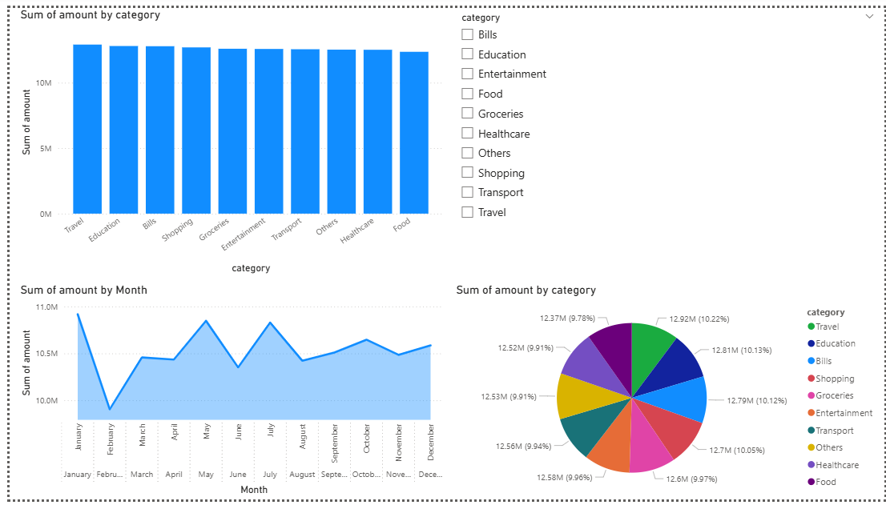

6. Optional Analytical Enhancements
Basic analytical techniques can be applied to enhance the system, such as:
• Identifying highest spending categories
• Predicting future expenses based on past data
• Setting budget limits and alerts
These features improve the overall functionality of the system.

EXPEREMENTATION AND CODE

Code Structure
The project was implemented using Python in Azure Databricks. The overall code is divided into several functional modules:
- Data Loading:
Transaction data is loaded from Azure Blob Storage into Spark DataFrames using secure access keys.
- Data Preprocessing:
Data cleaning operations such as handling missing values, formatting columns, and schema validation are performed.
- Analysis Module:
The system performs transaction analysis including:
  - Debit vs Credit transaction count
  - Location-wise transaction distribution
  - Channel usage (Online, ATM, etc.)
- Fraud Detection Logic:
Suspicious transactions are identified based on:
  - High transaction amounts
  - Multiple login attempts
- Visualization:
Results are displayed using bar charts, tables, and graphs for better understanding.

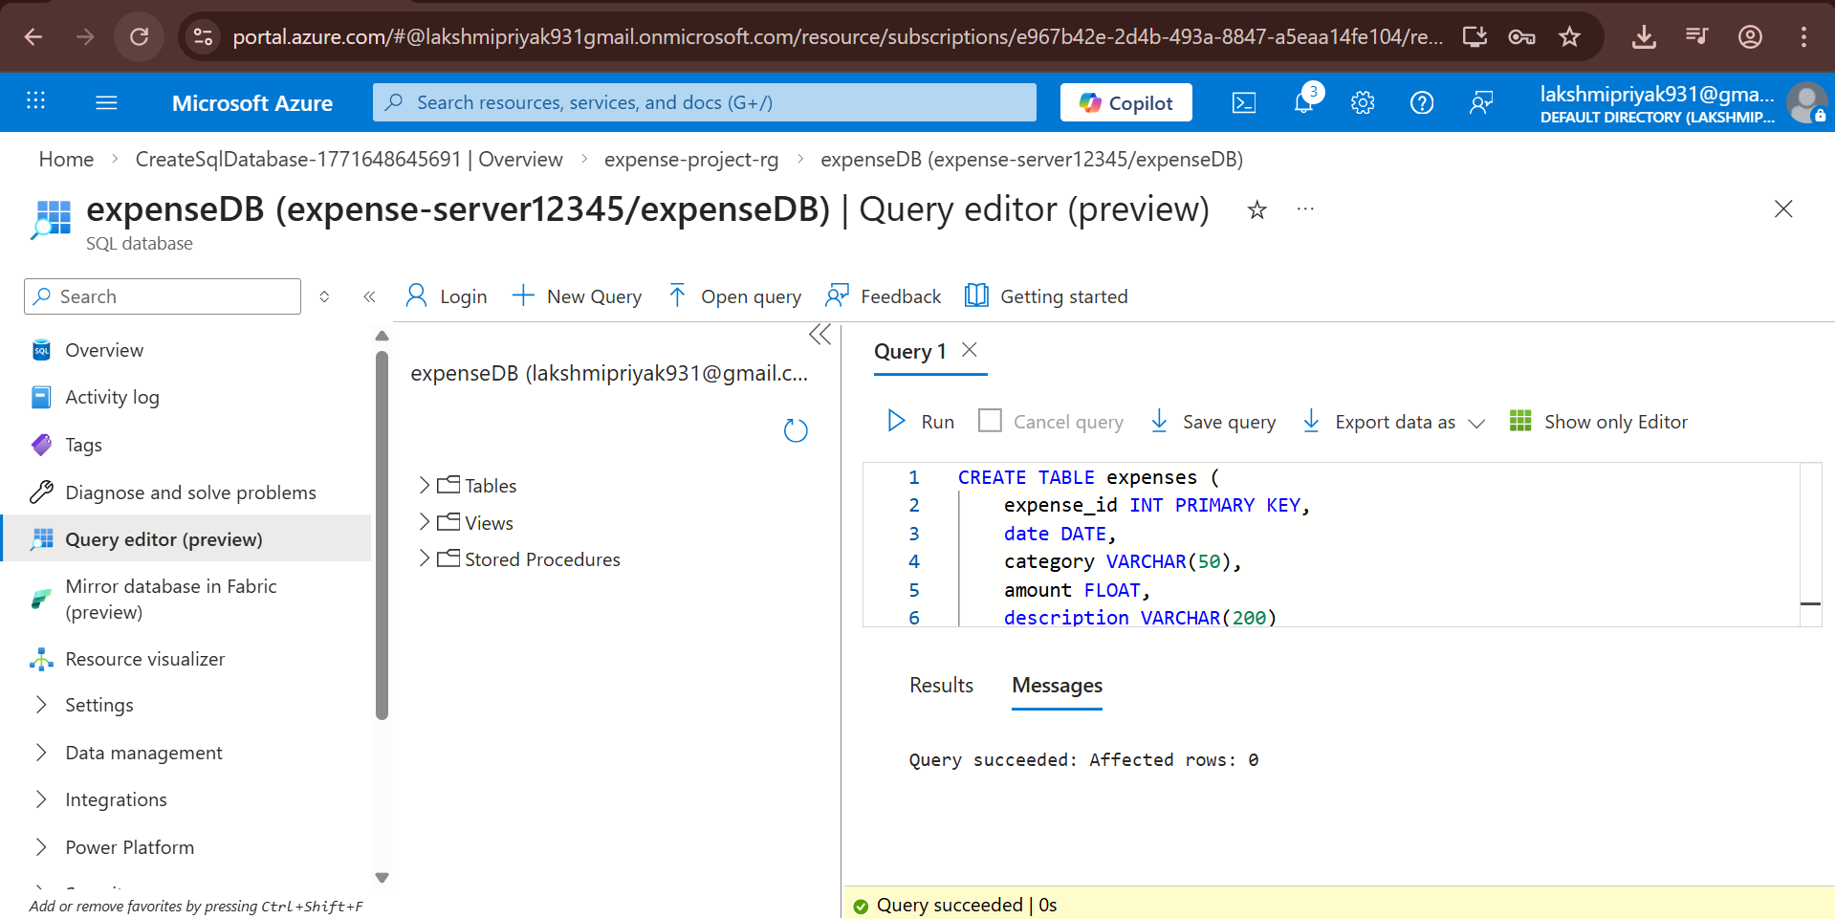

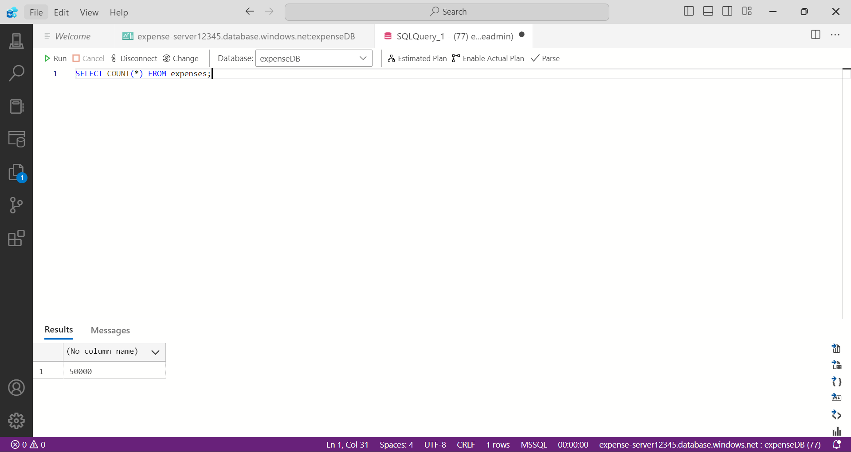

Experimentation

Steps Performed
- Loaded the financial transaction dataset into Azure Databricks.
- Performed data cleaning and preprocessing.
- Analysed transaction patterns such as:
  - Debit vs Credit transactions
  - Location-wise transactions
  - Channel-based usage
- Detected high-value and suspicious transactions.
- Applied a machine learning model (Logistic Regression) for fraud detection.
- Visualized results using charts and tables.

Performance Analysis
- Processing Speed:
High processing speed due to distributed cloud-based Spark computation.
- Scalability:
The system efficiently handles large-scale financial datasets.
- Accuracy:
The fraud detection model successfully identifies suspicious transactions.
- Resource Usage:
Minimal local resource usage since computation is performed in the cloud.

Conclusion of Experimentation
The experimentation demonstrates that cloud-based analytics using Azure Databricks is highly efficient and reliable for financial transaction analysis. The system successfully identifies transaction patterns and detects suspicious activities. The results highlight that cloud computing provides superior scalability, performance, and flexibility compared to traditional systems.

Overview of Our Website

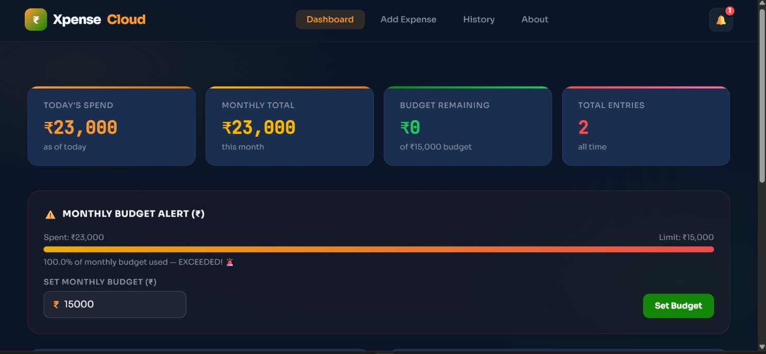

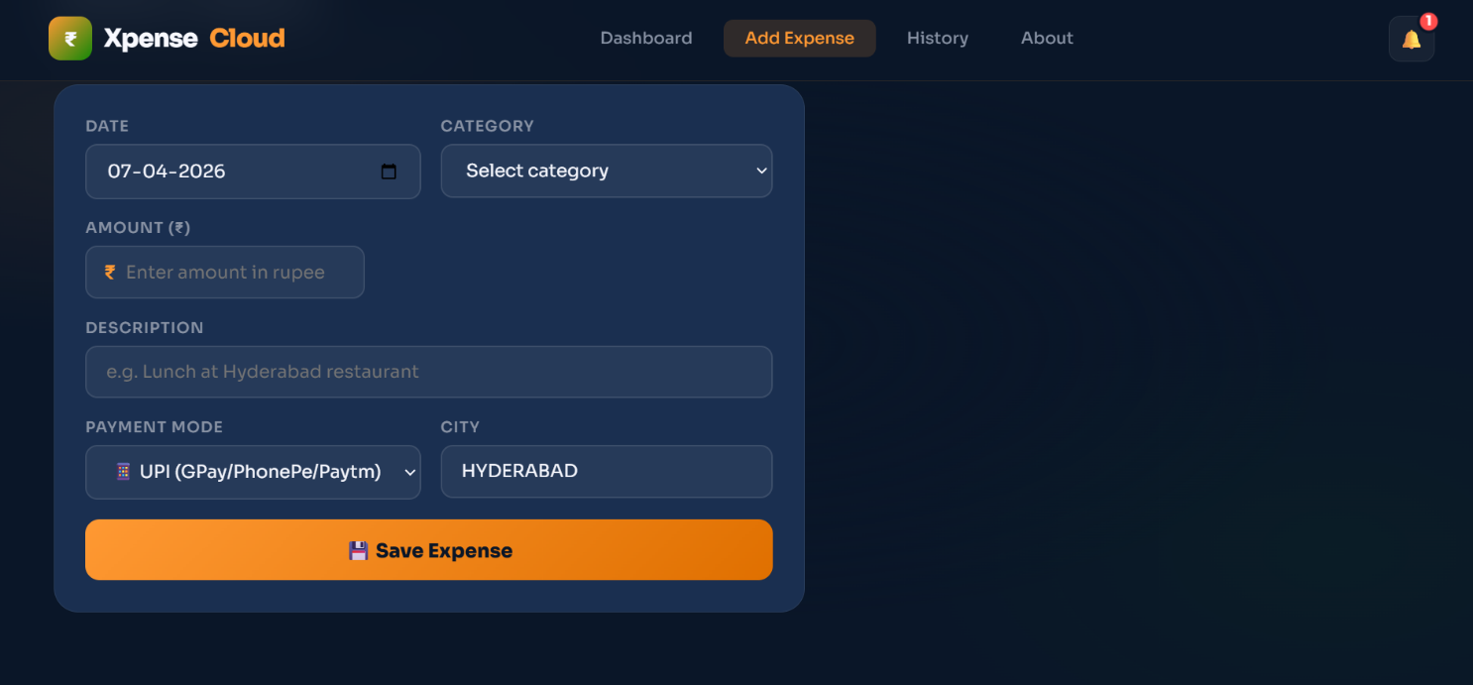

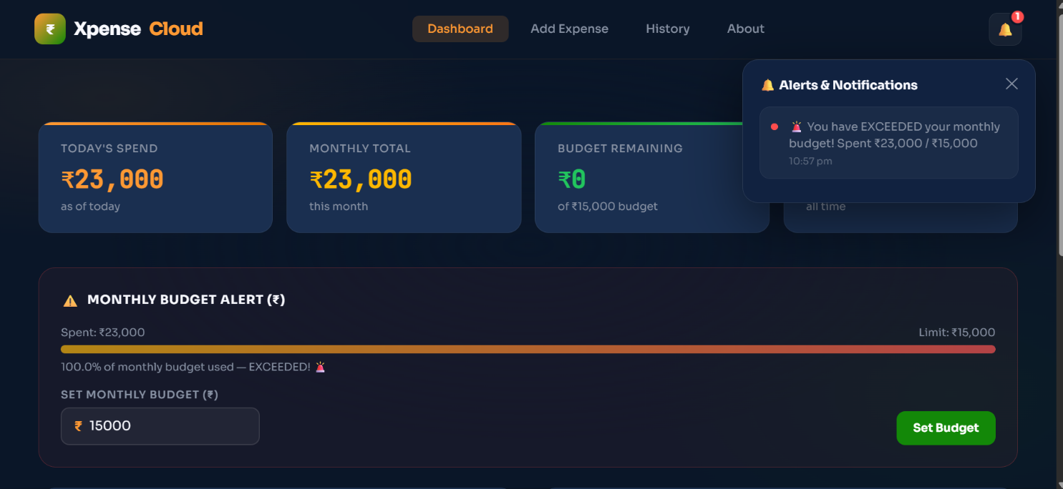
Unique Feature of our website:

RESULT

Results of the Cloud-Based Daily Expense Visualization Dashboard using Microsoft Azure
The implementation of the Cloud-Based Daily Expense Visualization Dashboard produced significant results that demonstrate the effectiveness of cloud computing in analysing financial data. The project successfully utilized Azure Blob Storage and Azure Databricks to process and analyse expense data efficiently. The system enabled accurate visualization, pattern identification, and detection of unusual expense behaviour.
The results clearly highlight how cloud-based platforms can be used for efficient financial data management, real-time insights, and intelligent decision-making.

1. Expense Pattern Analysis
The system analysed daily expense data to understand spending behaviour and trends. The following observations were obtained:
- Daily expenses showed clear patterns, with higher spending observed during weekends and specific periods.
- Category-based analysis (Food, Travel, Shopping, etc.) indicated that most expenses were concentrated in essential and lifestyle categories.
- Expense trends varied across different time periods, helping in understanding user spending habits.
These insights demonstrate the ability of the system to extract meaningful patterns from financial data.

2. High-Value and Unusual Expense Detection
One of the key objectives of the project was to identify unusual or high-value expenses. This was achieved by analysing:
- Expense amount
- Frequency of transactions
- Spending behaviour patterns
Expenses that exceeded a predefined threshold or showed abnormal patterns were flagged as suspicious.
This helps in:
- Monitoring unnecessary spending
- Identifying potential financial risks
- Improving budgeting decisions

3. Performance Evaluation

Time Efficiency
The use of Azure Databricks enabled fast processing of expense data using distributed computing. Data operations were executed efficiently compared to traditional systems.

Scalability
The cloud-based system handled increasing data volumes without performance degradation. It can easily scale to accommodate larger datasets.

4. Visualization and Insight Generation
Visualization played a crucial role in interpreting the results. The system generated:
- Bar charts showing category-wise expenses
- Pie charts representing expense distribution
- Time-series graphs showing daily expense trends
- Tables displaying detailed transaction data
These visualizations made complex data easy to understand and supported better financial decision-making.

5. Machine Learning-Based Observations
A basic machine learning model (Logistic Regression) was applied to identify unusual spending behaviour.
The model helped to:
- Classify normal and abnormal expenses
- Detect high-risk spending patterns
- Improve accuracy in identifying anomalies
This demonstrates how machine learning can enhance financial analytics when combined with cloud platforms.

6. Learning Outcomes
Through this project, the following key learnings were achieved:
- Understanding of cloud-based data storage and processing
- Hands-on experience with Azure Databricks and Spark
- Knowledge of expense data analysis
- Practical exposure to data visualization techniques
- Understanding of anomaly detection using machine learning

Final Overview
The results of the project clearly demonstrate that cloud-based analytics is an efficient and reliable approach for expense data analysis. Azure Databricks proved to be a powerful platform for handling large datasets, performing analytics, and generating meaningful insights.
The system successfully identified spending patterns, detected unusual expenses, and presented results in a visually understandable format. Overall, the project achieved its objectives and demonstrated how cloud computing, data analytics, and machine learning can be integrated to build a scalable and efficient expense visualization system.
The outcomes of this project highlight its real-world applicability in personal finance management and provide a strong foundation for future enhancements such as real-time expense tracking and advanced predictive analytics.

CONCLUSION
The Cloud-Based Daily Expense Visualization Dashboard using Microsoft Azure project successfully demonstrated how cloud computing can be effectively used to manage and analyse personal financial data. By utilizing Microsoft Azure services such as Azure Blob Storage and Azure Databricks, the project provided a scalable and efficient solution for storing, processing, and visualizing daily expense data.
Through this project, expense data was analysed to identify spending patterns, category-wise distribution, and trends over time. The system helped in understanding user spending behaviour by classifying expenses into different categories such as food, travel, and shopping. This analysis made it easier to track daily expenses and manage personal finances more effectively.
The project also demonstrated the identification of high-value and unusual expenses, which helps users monitor unnecessary spending and make better financial decisions. The use of data visualization techniques such as bar charts, pie charts, and graphs enhanced the understanding of financial data by presenting it in a simple and clear format.
Additionally, the integration of a basic machine learning model added intelligence to the system by enabling the detection of abnormal spending patterns. This shows how cloud-based platforms can support not only data visualization but also predictive and analytical capabilities with minimal infrastructure.
Overall, the project successfully achieved its objectives by developing a cloud-based system for expense tracking and visualization. It highlighted the importance of cloud computing in handling financial data efficiently, providing real-time insights, and improving decision-making.
This project serves as a strong foundation for future enhancements such as real-time expense tracking, mobile application integration, advanced machine learning models for expense prediction, and personalized financial recommendations. Therefore, it is highly relevant for real-world applications in personal finance management and smart budgeting systems.

REFERENCES

Academic and Technical References
- Microsoft Azure Documentation
Microsoft Azure. Azure Blob Storage Documentation.
Available at: https://learn.microsoft.com/en-us/azure/storage/blobs/
This reference was used to understand cloud-based data storage, scalability, and secure handling of expense datasets.

- Azure Databricks Documentation
Microsoft Azure. Azure Databricks Overview and Tutorials.
Available at: https://learn.microsoft.com/en-us/azure/databricks/
This source provided guidance on data processing using Apache Spark, data analysis, and visualization techniques applied in the expense dashboard.

- Python Official Documentation
Python Software Foundation. Python Documentation.
Available at: https://docs.python.org/3/
Referenced for Python programming, data manipulation, and analysis techniques used in the project.

- Expense and Personal Finance Analysis
Gitman, L. J., & Joehnk, M. D. (2011). Personal Financial Planning.
This reference helped in understanding expense tracking, budgeting, and financial behaviour analysis.

- Big Data Analytics Concepts
Chen, M., Mao, S., & Liu, Y. (2014). Big Data: A Survey.
This paper provided insights into large-scale data processing and analytics relevant to cloud-based expense systems.

- Data Visualization Techniques
Few, S. (2009). Now You See It: Simple Visualization Techniques for Quantitative Analysis.
This reference was used to understand effective ways of presenting expense data through charts and dashboards.

- Cloud Computing Concepts
Armbrust, M., et al. (2010). A View of Cloud Computing. Communications of the ACM.
This provided the theoretical background of cloud computing and its advantages in scalability and performance.

Online References
- https://learn.microsoft.com/en-us/azure/
- https://learn.microsoft.com/en-us/azure/databricks/
- https://spark.apache.org/
- https://www.kaggle.com (for expense datasets)
- https://towardsdatascience.com (for data analytics and machine learning concepts)
- https://www.geeksforgeeks.org (for Python and data analysis concept

